PHASE 11 – KNOWLEDGE CREATION & REUSE
Incident Lifecycle Automation in ServiceNow
Implementation Documentation with ServiceNow Screenshot Evidence

1. Phase Objective
Retain the troubleshooting solution as reusable Knowledge so future VPN incidents can be handled consistently.

2. Implementation Details
The approved Knowledge article KB0010001 – VPN Connection Troubleshooting was retained as reusable support knowledge.
The article contains possible causes, resolution steps, and verification guidance for VPN connectivity problems.
The article was searched from INC0010014 and attached to the incident. This demonstrates Knowledge Management reuse within the incident lifecycle.

3. Configured / Verified Records
Field | Value
Knowledge Article | KB0010001
Title | VPN Connection Troubleshooting
Knowledge Base | IT
Version | v1.0
State | Approved
Incident Reuse | Attached to INC0010014

4. Screenshot Evidence
Only evidence relevant to this phase is included below.
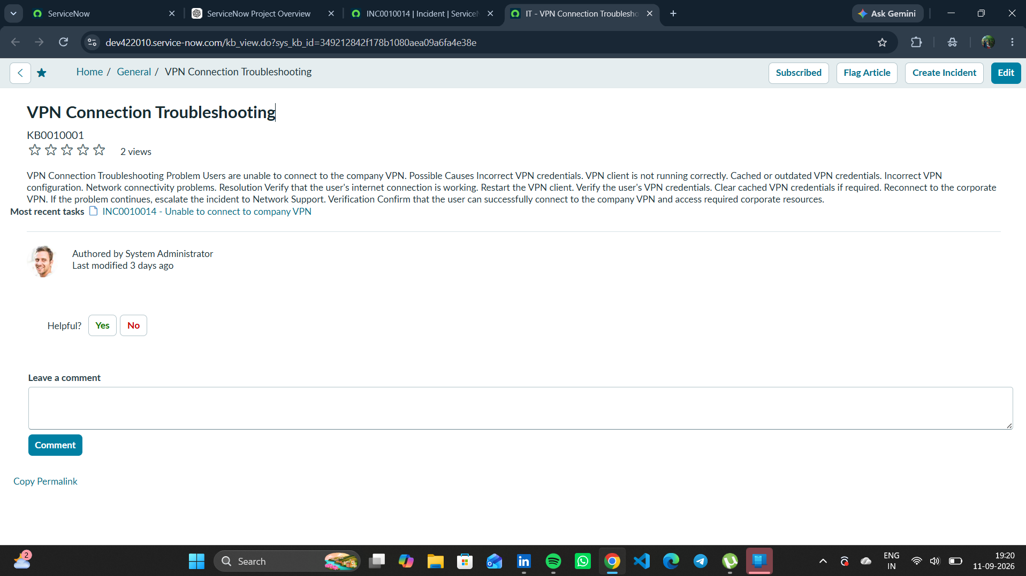
Figure 1. KB0010001 – VPN Connection Troubleshooting used as approved Knowledge evidence.

5. Phase Outcome
- KB0010001 was available as an approved Knowledge article.
- The troubleshooting procedure was reusable for future incidents.
- Knowledge Management was incorporated into the incident lifecycle.
Status: COMPLETED

6. Evidence Files
- e56aff66-f975-435f-9cdd-1ef2b0db658d.png

